VISHWAKARMA UNIVERSITY
Academic Year: 2025-26 | Semester II
ADVANCED WEB TECHNOLOGY
NAME OF THE STUDENT : | Aaditya Dhanwate
DEPARTMENT : | ARTIFICIAL INTELLIGENCE & DATA SCIENCE
CLASS / DIV. : | TY / A
SRN : | 31230319
ROLL NO. : | 8

ASSIGNMENT NO.: 04
Create a To-Do Application using React and Deploy it
OBJECTIVE:
• Build a To-Do (Task Manager) application using React JS with add and complete task functionality
• Implement dark/light mode toggle and task completion with strikethrough styling
• Deploy the React application to a live hosting platform (Vercel)

Problem Statement: Create a To-Do application named "Task Spark" using React JS that allows users to add tasks, mark them as complete (with strikethrough), and toggle between dark and light modes. The application must be deployed to a live URL using Vercel.
Output:
1. Task Spark – To-Do Application UI (Dark Mode)
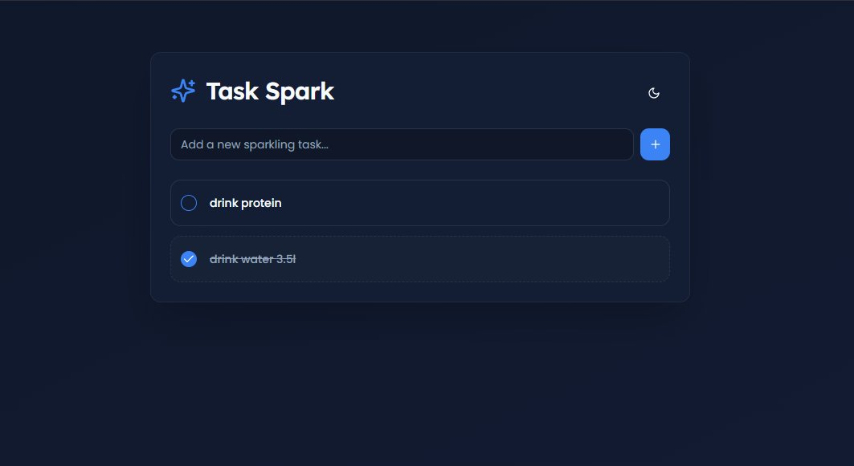
2. Application Running on Deployed URL (task-manager-two-smoky.vercel.app)
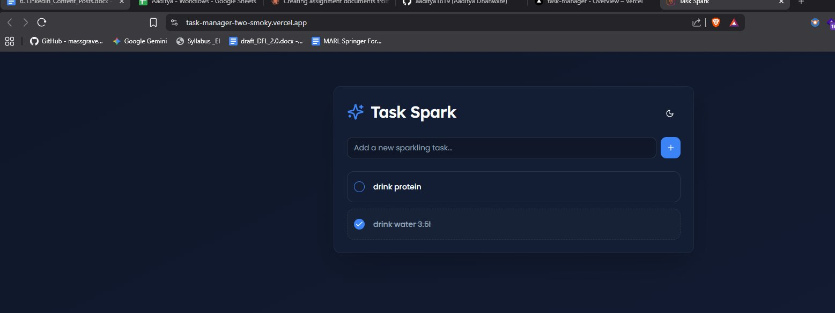
3. Vercel Production Deployment Dashboard
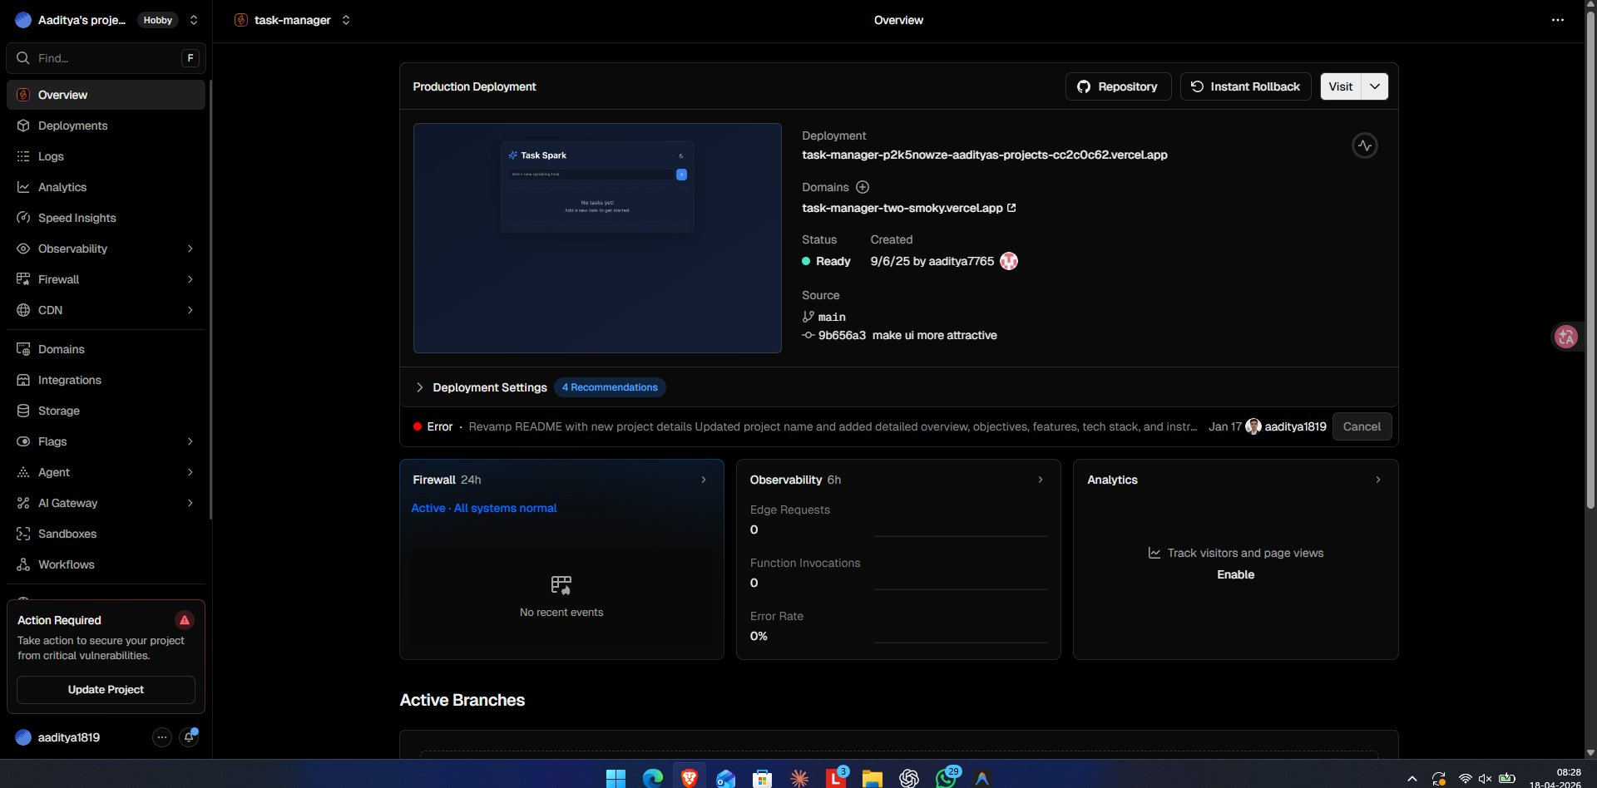

Conclusion:
In this assignment, a fully functional To-Do application called "Task Spark" was built using React JS. The app supports adding new tasks, marking tasks as complete with a visual strikethrough, and toggling between dark and light themes. The application was successfully deployed to Vercel and is accessible via a live public URL (task-manager-two-smoky.vercel.app), demonstrating end-to-end React development and cloud deployment skills.

